SPECTRE / MACS3 eComms
Lexicon Surveillance Platform
Lexicon Compile Service
Complete Technical Reference — Cloud Run Service
Covers the complete implementation: translation pipeline, operator language,
language and script handling, wildcards and emoji, AND / AND NOT / NEAR / FOLLOWEDBY
semantics, validation and exception handling, Hyperscan flags, the term-number
expression-ID scheme, and the complete REST API surface.
Document version 1.0
Reflects the complete current implementation, ground-truthed against source

Table of Contents

1. Executive Summary
The Lexicon Compile Service is a Spring Boot 4 / Java 21 microservice, deployed on Google Cloud Run, that translates compliance lexicon terms — written in a human-readable operator language — into Hyperscan-compatible PCRE patterns, validates every pattern against the real Intel Hyperscan compiler, and optionally packages a combined multi-pattern Hyperscan database for batch consumption. It is the single point in the platform where lexicon rule text becomes an executable pattern, and every other component (the interactive Lexicon Scanner Service, and the batch Lexicon Scan Engine) depends on its output being correct.
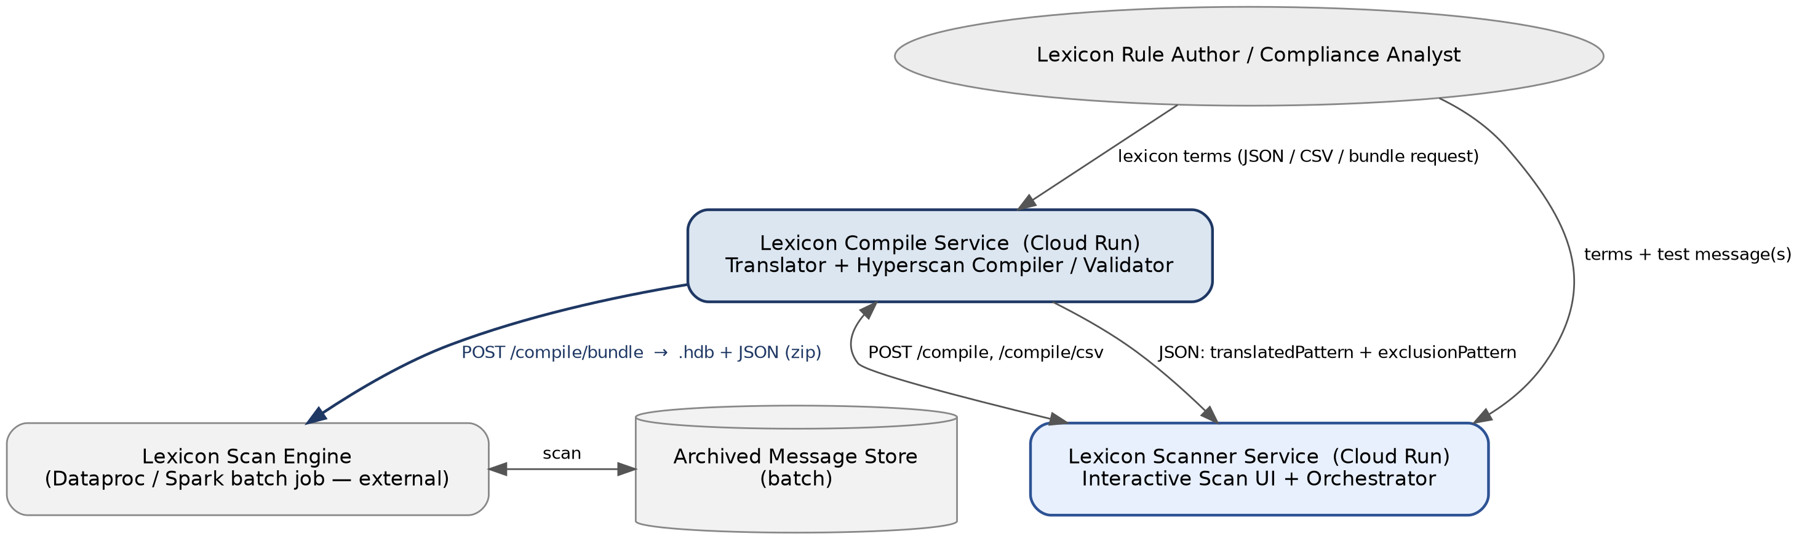
Figure 1: The Compile Service's place in the wider platform. It has two structurally different consumers — the Scanner Service, which reads JSON and combines patterns itself, and the Scan Engine, which reads only a compiled database file.

1.1 Scope of This Document
This document describes the complete current implementation of the Lexicon Compile Service — not only the most recent changes, but the full feature set as it exists today: the translation pipeline and grammar, every supported operator, multi-language and script handling, wildcard and literal-character handling, emoji support, the complete validation and exception-handling surface, the Hyperscan flag model, the two AND NOT implementations, pattern-complexity protection, the term-number-based Hyperscan expression ID scheme used by the bundle endpoint, and the REST API.

1.2 Technology Stack
Layer | Choice
Language / Runtime | Java 21, Spring Boot 4.0.6
Pattern engine | Intel Hyperscan 5.4.0-2.0.0, via the com.gliwka.hyperscan-java wrapper
CSV parsing | OpenCSV
Language/script detection | Custom per-codepoint Unicode script classifier, complemented by Apache Tika's language detector
Deployment | Google Cloud Run
Base package | com.db.macs3.ecomms.spectre

2. Architecture and Deployment

2.1 Position in the Platform
The Compile Service has two structurally different consumers, and this fact shapes several design decisions covered later in this document (most notably why AND NOT has two separate implementations):
- Lexicon Scanner Service — calls POST /compile or /compile/csv, reads the JSON response, and compiles/scans the returned patterns itself for its interactive UI.
- Lexicon Scan Engine (external Dataproc/Spark batch job) — calls POST /compile/bundle and consumes only the returned Hyperscan .hdb database file for large-scale batch scanning. It never reads the accompanying JSON.

2.2 Deployment
Property | Value
Platform | Google Cloud Run (containerised, stateless, auto-scaling)
Container build | 2-stage Docker build, JDK 21 base image, no native-library compile step (Hyperscan's native .so ships inside the com.gliwka.hyperscan JAR and is extracted to java.io.tmpdir at runtime)
Health checks | GET /api/lexicon/health (application-level) and GET /actuator/health (Spring Boot Actuator, includes a Hyperscan self-test component)
Startup behaviour | A @PostConstruct self-test compiles a trivial pattern through the real Hyperscan library. If it fails, the Spring context does not start — there is deliberately no fallback engine, so a broken native-library deployment fails fast at container startup rather than at first request.

3. Translation Pipeline (Control Flow)
Every term description passes through five stages. Each stage owns a distinct, non-overlapping class of validation, so any rejection points at a single, specific, addressable cause rather than a generic failure.
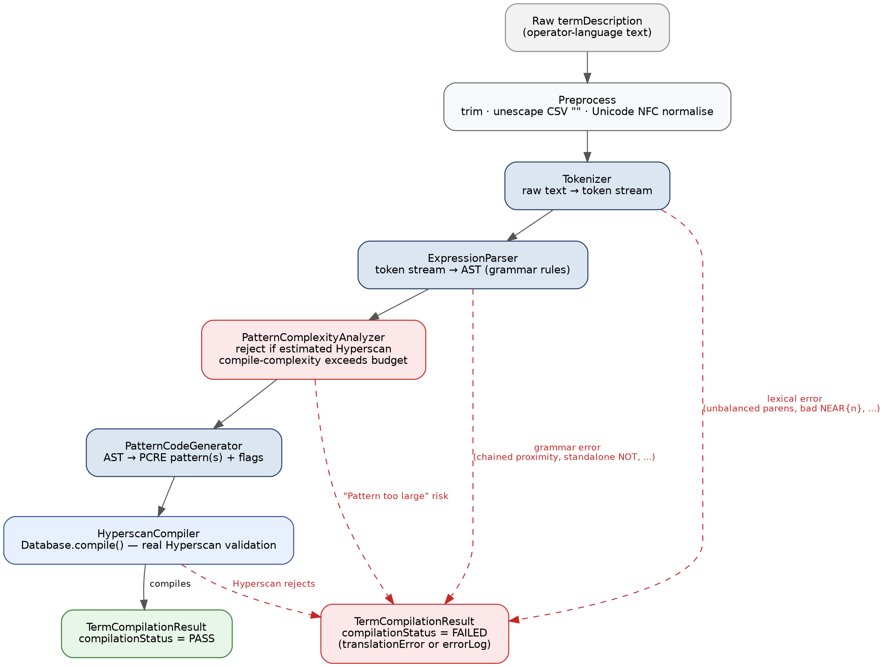
Figure 2: The complete translation control flow, including every point at which a term can be rejected.

3.1 Stage-by-Stage Responsibility
Stage | Class | Responsibility
0. Preprocess | TermSyntaxTranslator.preprocess() | Trim whitespace; unescape CSV-style doubled quotes ("" → "); Unicode NFC normalisation via ICU4J, so visually-identical characters encoded differently are treated identically.
1. Tokenize | Tokenizer | Raw text → token stream. ALL lexical-level validation happens here (see section 10.1).
2. Parse | ExpressionParser | Token stream → Abstract Syntax Tree (AST), via recursive-descent parsing following the grammar in section 5.6. ALL grammar-level validation happens here (see section 10.2).
3. Complexity check | PatternComplexityAnalyzer | Estimates whether the AST is likely to produce a pattern Hyperscan will reject as "too large", BEFORE any pattern text is generated (see section 11).
4. Generate | PatternCodeGenerator | AST → one or two PCRE pattern strings (required pattern, and — for AND NOT terms — an exclusion pattern) plus a Hyperscan flag bitmask. No further validation occurs at this stage; every structural issue has already been caught upstream.
5. Validate | HyperscanCompiler | Calls the REAL Hyperscan compiler (Database.compile()) on the generated pattern(s) — not just a PCRE syntax check. This is the only stage that can catch a pattern that is syntactically well-formed PCRE but that Hyperscan's own compiler still rejects (including "Pattern is too large" cases the complexity analyzer's heuristic did not anticipate).

4. Request Types: Natural Language and Regex
Every term compiled through the typed bundle endpoint (and conceptually, every term in the platform) is one of two types, carried by the TermType enum. This is a root-level property of a /compile/bundle request — one request, one term type, applied uniformly to every term in it.
Type | JSON value | What termDescription contains | Pipeline used
Natural Language | "Natural Language" | Operator-language text (OR, AND, AND NOT, NEAR{n}, FOLLOWEDBY{n}, wildcards, quoted phrases — the full grammar in this document) | The complete 5-stage pipeline in section 3
Regex | "Regex" | An already-valid Hyperscan-compatible PCRE pattern, supplied verbatim by the caller | No translation at all — Hyperscan-validated directly, with script-aware flags auto-derived from the pattern's own content (section 13.4)

Design note
Regex-type terms bypass the Tokenizer, ExpressionParser, PatternComplexityAnalyzer, and PatternCodeGenerator entirely — none of this document's grammar, validation, or complexity-estimation content applies to a Regex-type term. The only processing applied is Hyperscan compilation (real validation, not just PCRE syntax checking) and automatic script-aware flag selection.

The /compile and /compile/csv endpoints do not carry a term-type distinction at all — every term submitted to them is always treated as Natural Language and passed through the full pipeline. Only the typed bundle endpoint (/compile/bundle) supports Regex-type terms.

5. The Operator Language: Complete Reference

5.1 Grammar and Operator Precedence
The operator language is parsed by recursive descent, with the following precedence (lowest to highest binding):
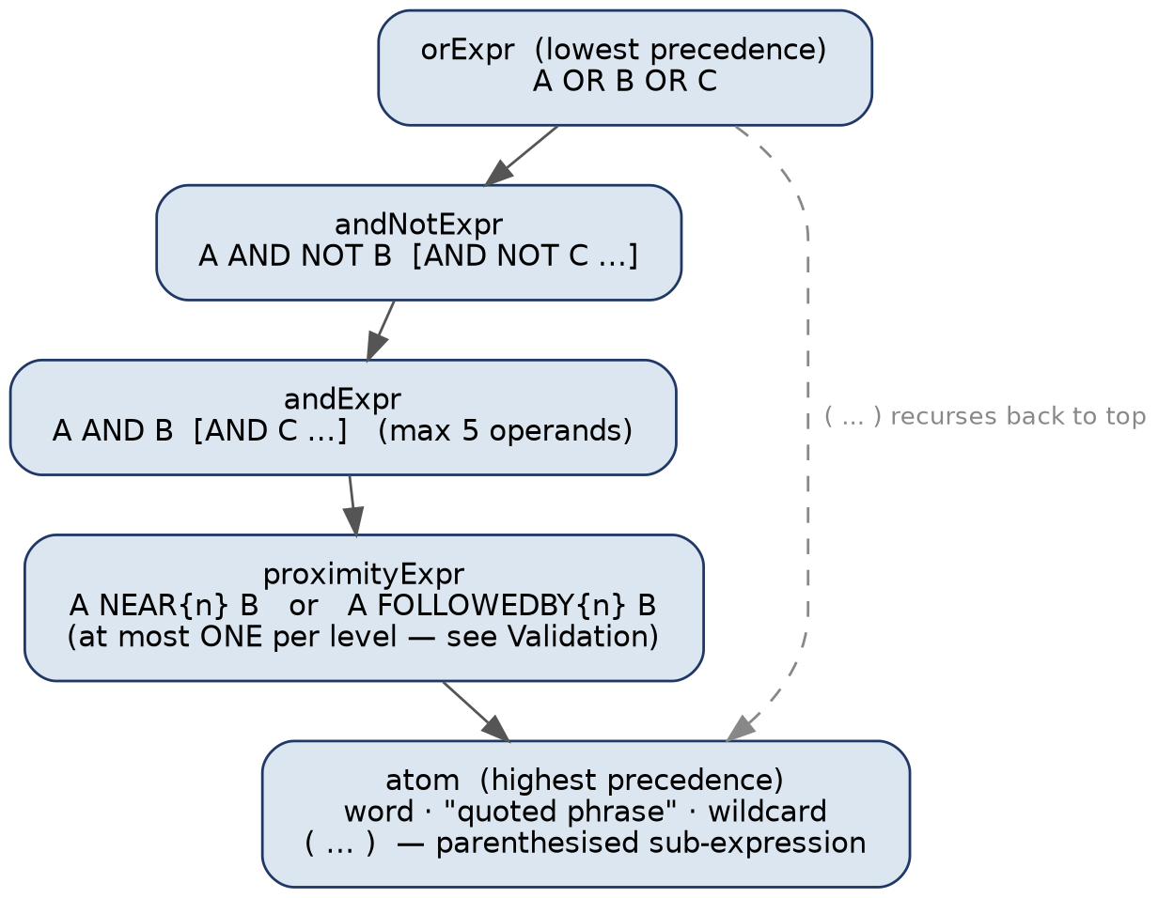
Figure 3: Operator precedence, highest-binding at the bottom. Parentheses always resolve to the top of this chain, regardless of nesting depth.

5.2 OR
Alternation — the term matches if any operand matches.
price OR spread OR stock
→ (?:price|spread|stock)
OR is the lowest-precedence operator, so it separates the widest groupings in a term. Every other operator binds more tightly than OR.

5.3 AND: Co-occurrence, Any Order, No Distance Limit
"price AND rigging" means both words must appear somewhere in the message, in any order, with no limit on how far apart they are. This compiles to a single genuinely correct Hyperscan pattern using the same bidirectional-alternation technique NEAR/FOLLOWEDBY use for a bounded gap, just with the gap made unbounded:
price AND rigging
→ (?:price[\s\S]*rigging|rigging[\s\S]*price)
[\s\S]* matches any character, any number of times — ordinary PCRE alternation and repetition, fully within Hyperscan's real capabilities. For three or more operands, every ordering is enumerated the same way: "A AND B AND C" produces all six A/B/C orderings joined by OR:
A AND B AND C → (?:
A[\s\S]*B[\s\S]*C | A[\s\S]*C[\s\S]*B |
B[\s\S]*A[\s\S]*C | B[\s\S]*C[\s\S]*A |
C[\s\S]*A[\s\S]*B | C[\s\S]*B[\s\S]*A
)

Operand ceiling: 5
A term may have at most 5 AND operands at one level. Each additional operand multiplies the permutation count (5! = 120 already; 6! = 720), and beyond the ceiling the resulting pattern reliably becomes too large for Hyperscan to compile. This is enforced in ExpressionParser, before any pattern is generated:
Too many AND operands at the same level (6) in term: '...'. A maximum of 5 is
supported — each additional operand multiplies the size of the resulting
Hyperscan pattern. Split this term into multiple simpler lexicon terms instead.

Worked example
Message | "price AND rigging" — result
"There's price change and market rigging is going on" | MATCHES — both words present, in that order, with other words between them
"There's price change" | Does NOT match — "rigging" never appears

Historical note: an earlier revision was wrong about this
AND was previously documented and implemented as (?=.*A)(?=.*B)(?=.*C).* — a chain of positive lookaheads. Hyperscan supports no lookaround of any kind (it is a linear-time, DFA/NFA-based multi-pattern matcher, not a backtracking engine), so that pattern was never actually compilable as documented. In practice every AND term silently degraded to OR semantics — "price AND rigging" behaved exactly like "price OR rigging". This was corrected by removing lookahead from the design entirely.

5.4 AND NOT: Two Different Implementations for Two Different Callers
"price AND NOT change" means price must appear, and change must NOT appear anywhere in the same message. Unlike AND, this cannot be compiled into one ordinary Hyperscan pattern — "absent from the whole text" is exactly what negative lookaround exists to express, and Hyperscan has none. Because the Compile Service has two structurally different consumers (section 2.1), AND NOT is implemented two different, independently correct ways.
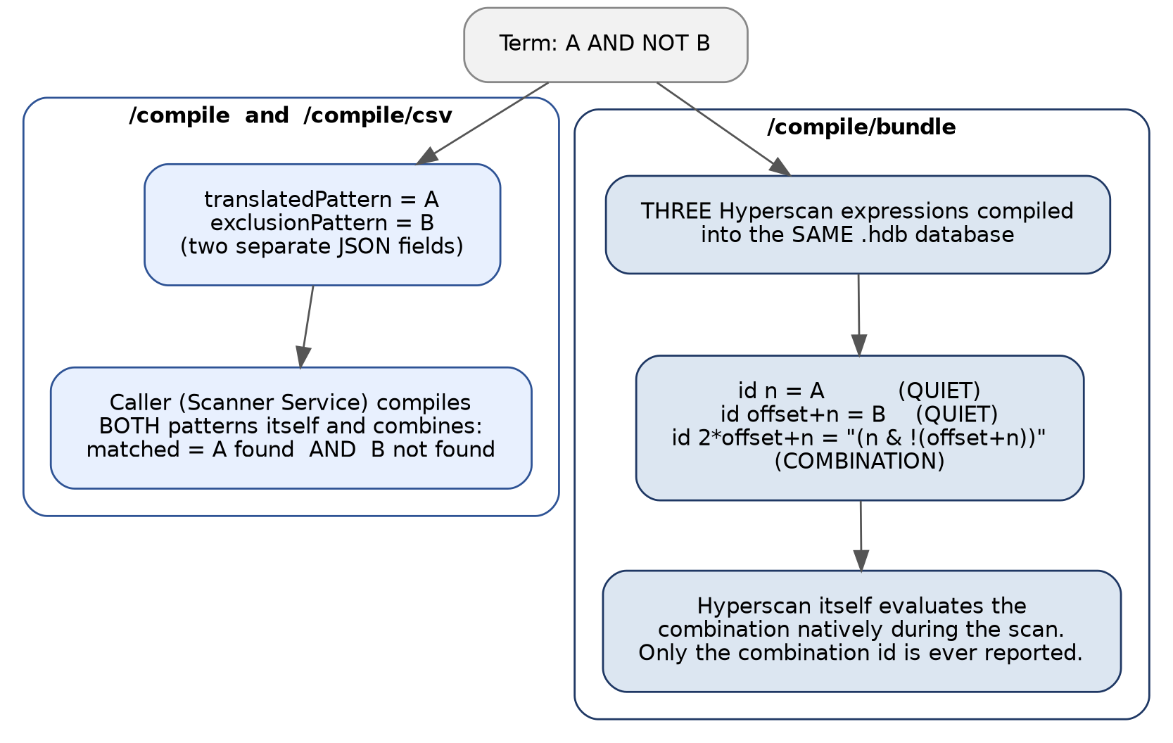
Figure 4: AND NOT's two implementations. The JSON-reading caller combines two patterns itself; the database-only caller gets the combination baked natively into the compiled Hyperscan database.

5.4.1 /compile and /compile/csv: the two-pattern JSON contract
These endpoints return two independent, separately Hyperscan-validated patterns. The caller is responsible for combining them:
{
"translatedPattern": "price",
"requiresExclusionCheck": true,
"exclusionPattern": "(?:change)"
}
A term is correctly matched only when:
translatedPattern DOES match the message AND
exclusionPattern does NOT match the message
Both patterns are validated by Hyperscan's real compiler independently at compile time — if either is rejected, the whole term is reported FAILED. Chained exclusions ("A AND NOT B AND NOT C") combine B and C into one exclusionPattern via OR — the term is excluded if either is present.

5.4.2 /compile/bundle: a native Hyperscan logical combination
The bundle endpoint's .hdb file is frequently the only artifact its consumer (the Lexicon Scan Engine) reads, with no JSON in the loop at all. For this endpoint, AND NOT is compiled directly into the database using Hyperscan 5.0+'s native logical combination feature: a compiled expression whose pattern text is a boolean formula over other expressions' IDs (&, |, !), evaluated natively by Hyperscan during the scan.
For an AND NOT term with term number n (section 14 covers how term numbers become Hyperscan IDs), three expressions are compiled into the combined database:
Expression ID | Pattern | Flags | Reported on its own?
n | the required pattern | normal + QUIET | No
offset + n | the exclusion pattern | normal + QUIET | No
2×offset + n | "(n & !(offset+n))" | COMBINATION only | Yes

where offset = (the largest term number in the request) + 1, computed once per request so the exclusion/combination ID ranges never collide with a real term number. QUIET suppresses a sub-expression's own match reporting, so a consumer that treats "any reported match = an alert" is automatically correct with zero per-term special-casing.

Worked example
"((don't forward) AND NOT (compliance OR legal))" as the only term, termId "lexicon_research_1::1" (term number 1, offset = 2):
{ "termId": "lexicon_research_1::1", "translatedPattern": "don't forward",
"requiresExclusionCheck": true, "exclusionPattern": "(?:(?:compliance|legal))",
"hyperscanExpressionId": 5 }
Compiled: id 1 = "don't forward" (QUIET), id 3 = "(?:(?:compliance|legal))" (QUIET), id 5 = "(1&!3)" (COMBINATION). Scanning "Please don't forward this message to compliance or legal": both id 1's and id 3's patterns are present, so (1 AND NOT 3) is false — Hyperscan reports no match at all, which is the correct outcome.
Dependency note
ExpressionFlag.COMBINATION and ExpressionFlag.QUIET were added to com.gliwka.hyperscan-java in its v1.0.0 release; this project pins the wrapper's v2.0.0 line (5.4.0-2.0.0), which post-dates that release. If a future dependency change ever removed these constants, every affected call site would fail to compile with an unambiguous "cannot find symbol" error naming the exact missing flag — not a silent behaviour change.

5.5 NEAR{n}: Bidirectional Proximity
"A NEAR{n} B" matches when A and B both appear, in EITHER order, with at most n words (or a script-appropriate character distance — section 8) between them:
(price OR spread) NEAR{5} manipulate
→ (?:(?:price|spread)(?:\s+\S+){0,5}\s+manipulate|manipulate(?:\s+\S+){0,5}\s+(?:price|spread))
The bidirectional form doubles the pattern relative to FOLLOWEDBY for the same operands — one alternative for each ordering.

5.6 FOLLOWEDBY{n}: Directional Proximity
"A FOLLOWEDBY{n} B" matches only when A appears FIRST, followed within n words by B. B appearing before A does not match:
don't FOLLOWEDBY{3} compliance
→ don't(?:\s+\S+){0,3}\s+compliance
Only one ordering is generated, so FOLLOWEDBY produces a smaller pattern than NEAR for the same distance and operands — worth choosing deliberately when order genuinely matters, both for correctness and for keeping compiled complexity down (section 11).

5.7 Validation: No Chained NEAR/FOLLOWEDBY at the Same Level
A term such as:
((termA OR termB OR termC) FOLLOWEDBY{5} (termD OR termE) FOLLOWEDBY{6} (termF OR termG))
chains two FOLLOWEDBY operators at the same grammar level. Each proximity operator's bidirectional pattern construction multiplies pattern size on its own; chaining two compounds that, and terms shaped like this reliably fail Hyperscan compilation even though the term description itself parses without error. This is rejected explicitly at translation time, before Hyperscan is ever invoked:
Cannot have multiple NEAR or FOLLOWEDBY operators at the same level in term: '...'
(found a second FOLLOWEDBY chained directly after the first). Wrap one side in
parentheses to nest them explicitly instead, e.g. '(A FOLLOWEDBY{n} B) FOLLOWEDBY{m} C'
Form | Accepted?
(termA FOLLOWEDBY{5} termD) FOLLOWEDBY{6} termF | Valid — explicit nesting, each side at its own grammar level
termA FOLLOWEDBY{5} termD FOLLOWEDBY{6} termF | Rejected — chained at the same level

The same rule applies to NEAR, and to any mix of NEAR/FOLLOWEDBY chained together. This rule is enforced by the grammar itself (ExpressionParser's proximityExpr production allows at most one proximity operator per level — see Figure 3), not by a size check after the fact — a term that genuinely needs two proximity relationships must say so explicitly with parentheses, which both resolves the ambiguity and keeps the resulting pattern bounded.

5.8 No Independent NOT Operator
NOT is only ever valid after AND
NOT (and the legacy ! shorthand) previously worked as a standalone prefix negation. It no longer does. A bare "NOT some text" is rejected at translation time with an explicit error directing the author to write "X AND NOT Y" instead. ! now has no special meaning at all — it is ordinary literal text, matched exactly.
This exists because, once AND NOT was fixed to have a real, correct implementation (section 5.4), a standalone NOT was no longer a coherent operator on its own — Hyperscan cannot express negation without an accompanying positive condition to combine it with (either via the two-pattern contract or the native combination mechanism), so "NOT X" in isolation has no way to be compiled correctly at all.

6. Wildcards and Literal Characters

6.1 Wildcards
Form | Example | Compiled
Trailing wildcard | manipulate* | manipulate\S*
Leading wildcard | *running | \S*running
Both | *manipul* | \S*manipul\S*

A wildcard (*) expands to \S* — zero or more non-whitespace characters — rather than the narrower \w* (word characters only). This is a deliberate choice: \S* also matches punctuation, hyphens, and non-ASCII characters directly attached to the word (e.g. "wordC-suffix" or "wordC123!"), which \w* would silently miss. This choice was reaffirmed once already, after a suggestion to narrow it to \w* for performance reasons was evaluated and rejected as a real semantic regression with no demonstrated performance benefit for the actual failure mode it was proposed to address.

6.2 Literal ? — Never a Quantifier
A bare ? in a term description is always treated as a literal question-mark character, never as PCRE's "zero or one" quantifier:
he?d kill
→ he\?d kill
This matters because lexicon terms are often typed by non-technical compliance authors who do not intend PCRE metacharacter semantics — "he?d" should mean the literal text some users type for "he'd" or similar, not an optional-e regex.

6.3 PCRE Metacharacter Escaping
Every literal character in a term description that has special meaning in PCRE (., +, (, ), [, ], {, }, ^, $, |, \, and others) is automatically backslash-escaped during code generation, so lexicon authors never need to think about regex syntax when writing ordinary text. Only the operator language's own reserved syntax (the OR/AND/NEAR/FOLLOWEDBY keywords, {n} distance braces, *, ?, quotes, and parentheses used structurally) carries special meaning — everything else in a term description is treated as literal text to match exactly.

7. Phrases

7.1 Quoted Phrases
Double-quoted text is treated as one literal phrase, matched exactly as written. Unlike a bare word, * and ? inside a quoted phrase are also escaped as ordinary literal characters, not treated as wildcard/literal-question-mark operators:
"please don't forward"
→ please\ don't\ forward (escaped as one literal unit)

7.2 Unwrapped Multi-Word Phrases
A run of bare words with no operator between them is automatically treated as one literal phrase — explicit parentheses are not required:
bomb this place OR blow this place up
→ (?:bomb this place|blow this place up)
Each OR-branch here ("bomb this place", "blow this place up") is a multi-word run with no OR/AND/NEAR/FOLLOWEDBY between the words, so the parser greedily collects consecutive WORD tokens into a single Phrase node. This reduced an authoring burden from an earlier revision that required explicit wrapping — (bomb this place) OR (blow this place up) — for the same result; both forms are still accepted, but the wrapping is now optional.

8. Language and Script Handling
Lexicon terms and messages are not restricted to English or to space-delimited scripts. The service classifies text by Unicode script family and chooses a different proximity-gap construction strategy depending on whether the script reliably uses whitespace between words.

8.1 Script Types and Gap Strategy
Script type | Examples | Space-delimited? | Gap strategy | Avg. chars/word
LATIN | English, French, German, Spanish, Russian, Greek | Yes | Word-based | 8
ARABIC | Arabic | Yes (RTL) | Word-based | 7
HEBREW | Hebrew | Yes (RTL) | Word-based | 7
DEVANAGARI | Hindi, Sanskrit, Marathi, Nepali | Yes | Word-based | 7
CJK | Chinese (Simplified/Traditional), Japanese Kanji | No | Character-based | 3
KANA | Japanese Hiragana/Katakana | No | Character-based | 3
HANGUL | Korean | Inconsistent — formal writing spaces eojeol, chat/SNS often omits them | Character-based (handles both cases safely) | 5
THAI | Thai, Lao, Myanmar | No | Character-based | 6
MIXED_CJK | Any pairing where at least one side is CJK/Kana/Hangul/Thai | N/A | Character-based (mandatory) | 4
MIXED_RTL | Arabic/Hebrew mixed with Latin-only | Yes (both sides) | Word-based | 8
MIXED | Any other multi-script combination | N/A | Character-based (conservative default) | 6

8.2 Word-Based vs. Character-Based Gaps
For a NEAR{n} or FOLLOWEDBY{n} relationship, the gap between the two operands is expressed one of two ways depending on the detected script:
- Word-based (e.g. Latin, Arabic, Hebrew): gap pattern (?:\s+\S+){0,n}\s+ — literally "0 to n whitespace-delimited words".
- Character-based (e.g. CJK, Thai, Korean): gap pattern [\s\S]{0,N} where N = n × avgCharsPerWord for the detected script — converting a word-distance into a character-distance ceiling, since these scripts have no reliable whitespace to count words by.
Korean is handled as character-based even though formal Korean writing does use spaces between eojeol (word-like units), because informal chat and social-media text frequently omits them. Character-based gap counting is correct for both the spaced and unspaced cases, so it is used unconditionally for Hangul rather than trying to detect which convention a given message follows.

8.3 Right-to-Left Scripts (Arabic, Hebrew)
Arabic and Hebrew are stored in Unicode in logical order — the order characters are typed and read, independent of how they are visually rendered right-to-left on screen. Hyperscan (like any regex engine) operates on the stored, logical-order bytes, so "A FOLLOWEDBY B" correctly means A sits at a lower byte index than B, exactly as intended, for purely Arabic or purely Hebrew text. When one operand of a proximity relationship is RTL and the other is LTR, the service exposes an isRightToLeft() flag so a caller can surface a warning about potential ordering ambiguity — the pattern still compiles and executes correctly against logical-order text, but the intended reading-order relationship between the two operands may not be what an author visually expects when mixing scripts.

8.4 Language Detection Mechanics
Script classification (ScriptDetector) works per-codepoint against the Unicode block/script the codepoint belongs to, then aggregates to a dominant ScriptType for a span of text — it does not depend on any statistical language model, so it is deterministic and fast.
This correctly distinguishes, for example, CJK text from Arabic text, and chooses the right gap strategy for each. It cannot, however, distinguish Chinese from Classical Japanese when text contains only CJK logographs with no Hiragana/Katakana hint to disambiguate — both are simply CJK. TikaLanguageSupport (Apache Tika's Optimaize language detector) exists as a narrow complement for exactly this case: when script detection alone cannot separate "zh" from "ja", Tika's statistical detector can narrow the language further, enabling a finer-grained avgCharsPerWord selection than the general CJK default.
This complement is deliberately not used broadly — its own documentation is explicit that statistical detection is unreliable on short strings (under 20 characters, which covers most lexicon term operands), produces noise on regex fragments, and is unnecessary whenever ScriptDetector has already resolved the script unambiguously (e.g. pure Hangul). The existing avgCharsPerWord values are deliberately conservative (generous upper bounds) specifically so that correctness does not depend on this narrower disambiguation being available.

9. Emoji Handling
Emoji and pictographic characters are recognised by codepoint range and encoded using PCRE's \x{...} hex-codepoint escape syntax, rather than being appended as raw literal UTF-8 bytes. This is deliberate: it keeps the generated pattern text unambiguous and independent of the source encoding of the term description file, and it makes the exact codepoint being matched auditable directly from the compiled pattern string.
insider OR 💰
→ (?:insider|\x{1F4B0})

9.1 Recognised Codepoint Ranges
A codepoint is treated as emoji (and encoded via \x{...}, with the UTF8 Hyperscan flag enabled) when it falls in any of the following Unicode blocks:
Range | Block
U+1F600 – U+1F64F | Emoticons
U+1F300 – U+1F5FF | Miscellaneous Symbols and Pictographs
U+1F680 – U+1F6FF | Transport and Map Symbols
U+1F700 – U+1F77F | Alchemical Symbols
U+1F780 – U+1F7FF | Geometric Shapes Extended
U+1F800 – U+1F8FF | Supplemental Arrows-C
U+1F900 – U+1F9FF | Supplemental Symbols and Pictographs
U+1FA00 – U+1FA6F | Chess Symbols
U+1FA70 – U+1FAFF | Symbols and Pictographs Extended-A
U+2600 – U+26FF | Miscellaneous Symbols
U+2700 – U+27BF | Dingbats
U+FE00 – U+FE0F | Variation Selectors (emoji presentation modifiers)
U+1F100 – U+1F1FF | Enclosed Alphanumeric Supplement (includes regional-indicator flag-letter pairs)

Any codepoint above U+007F (the ASCII range) that is NOT recognised as emoji by the ranges above is still handled correctly — it is appended to the pattern as a literal codepoint (not hex-escaped), with the UTF8 Hyperscan flag enabled so Hyperscan matches it correctly as a multi-byte UTF-8 sequence. Codepoints within ASCII range that are PCRE metacharacters are backslash-escaped as described in section 6.3; ASCII codepoints that are not metacharacters are appended as-is.

9.2 Mixed-Language and Emoji Terms
Emoji combine with any script without special-case handling — a term such as "insider OR 내부자 OR 💰" simply triggers UTF8 (and, since Korean is present, UCP) flags once, and each operand is encoded by whichever rule applies to it (literal ASCII, escaped PCRE metacharacter, literal non-ASCII codepoint, or \x{...} for emoji specifically).

10. Validation Rules
Validation is deliberately layered so that a rejection always identifies the specific stage and specific cause. Three layers exist, corresponding to three stages of the pipeline in section 3.

10.1 Lexical Validation (Tokenizer)
Rule | Rejected example | Error
Reserved keywords are case-sensitive | n/a — lowercase "or"/"and" are treated as literal words, not operators, by design | No error — this is intentional literal-text behaviour, not a rejection
NEAR/FOLLOWEDBY numeric syntax | term NEAR{} other | Malformed distance — {n} must contain a positive integer
Balanced parentheses | (price OR spread | Unbalanced parentheses
Closed quotes | "please don't forward | Unterminated quoted phrase
Meaningful content | *** OR ??? | Term must contain at least one real letter or digit

10.2 Grammar Validation (ExpressionParser)
- Chained NEAR/FOLLOWEDBY at the same level — rejected (section 5.7).
- AND operand ceiling (max 5) — rejected (section 5.3).
- Standalone NOT — rejected (section 5.8).

10.3 Complexity Validation (PatternComplexityAnalyzer)
Covered in full in section 11 — estimates whether a term's structure is likely to produce a pattern Hyperscan will reject as "too large", and rejects it before any pattern text is even generated.

10.4 Hyperscan-Level Validation (HyperscanCompiler)
The final and most authoritative validation layer: the generated pattern (or, for AND NOT, both generated patterns) is compiled through the REAL Hyperscan library via Database.compile() — not merely checked for valid PCRE syntax. This is the only layer that can catch a pattern that is syntactically well-formed but that Hyperscan's own compiler rejects for reasons the earlier heuristic layers did not anticipate.

11. Exception Handling

11.1 Exception Types
Exception | Thrown when | Surfaces as
TranslationException | A lexical, grammar, or complexity-budget rule (sections 10.1–10.3) is violated during translation of a Natural Language term | That term's compilationStatus = FAILED, translationError = the exception's message. Does NOT fail the whole request — other terms in the same request are unaffected.
CompileErrorException (Hyperscan library) | Hyperscan's own compiler rejects a syntactically-valid pattern (section 10.4) | That term's compilationStatus = FAILED, errorLog = Hyperscan's error message. Does NOT fail the whole request.
InvalidTermIdException | A /compile/bundle request's termId(s) don't satisfy the ::<n> term-number convention, or two terms share a term number (section 14) | HTTP 400 for the WHOLE request — checked and rejected before any term is compiled, since a Hyperscan ID collision would silently corrupt the combined database for every term in the request, not just the offending one.
MethodArgumentNotValidException (Spring bean validation) | A request fails @NotEmpty / @Valid annotation-level checks (e.g. an empty terms list) | HTTP 400 with field-level validation messages
MaxUploadSizeExceededException | An uploaded CSV file exceeds the configured size limit | HTTP 413 Payload Too Large
Any other unhandled exception | An unexpected internal error | HTTP 500 — logged server-side with full detail; response body is a generic message, not an internal stack trace

11.2 Per-Term Failure Isolation
A single bad term in a multi-term request (JSON, CSV, or bundle) never fails the whole request. Each term is compiled independently, and a FAILED term is reported alongside PASS terms in the same response — the caller sees exactly which term(s) failed and why, with the rest of the batch unaffected. This applies uniformly across all three compile endpoints.

11.3 GlobalExceptionHandler
A single @RestControllerAdvice class centralises the mapping from exception type to HTTP status and response body for every exception that is allowed to fail an entire request (as opposed to being caught and reported as a per-term FAILED result). This keeps the controller layer itself free of try/catch blocks and ensures a consistent error response shape across all endpoints.

12. "Pattern Is Too Large": Detection and Prevention
This section covers, in full, how the service anticipates and prevents Hyperscan's "Pattern is too large" compile failure — including the complete story of an earlier heuristic that was empirically wrong, because the reasoning behind the correction is as important as the current formula for anyone maintaining this code.

12.1 Why String Length Is Not the Right Signal
A term such as:
(((wordA word B OR wordC* wordD OR wordE* wordF OR wordG) FOLLOWEDBY{4}
(wordH* OR wordI wordJ* wordK OR wordL* wordM OR wordN)) FOLLOWEDBY{4}
(wordO* OR wordP* wordQ OR wordR* wordS OR wordT))
compiles to a 190-character pattern — nowhere near a string-length limit. "Pattern is too large" is a documented consequence of Hyperscan's compiled AUTOMATON STATE COUNT, not pattern text length: Intel's own issue tracker records a 32,000-repeat bounded quantifier on a simple pattern compiling fine, while a 73-repeat bounded quantifier on a pattern with additional structure fails.

12.2 The First Model Was Empirically Wrong
The first version of the complexity analyzer scored OR-branch width and wildcard presence, multiplying operand scores together at each NEAR/FOLLOWEDBY. Real Hyperscan testing directly falsified that model: a production term with a single NEAR over an 18-alternative and an 8-alternative OR group (no nesting) scored 480 under that model and compiled successfully in real Hyperscan. The term shown above, with two nested FOLLOWEDBY operators over much narrower 4-alternative groups, scored only 294 under the same model — and was rejected by real Hyperscan with "Pattern is too large". The score had the risk ranking exactly backwards.

12.3 The Reasoning Behind the Correction
A bounded gap such as (?:\s+\S+){0,4} requires the automaton to track "how many gap-words have been consumed so far" as part of its state — a handful of states (0 through 4) is cheap on its own, which is why the wide, single-level case compiled fine despite its size. But when one proximity operator's operand is itself a proximity operator, the automaton must track two independent gap-counters simultaneously for ambiguous partial matches — a PRODUCT of state spaces, not a sum. Nesting depth compounds multiplicatively; OR-branch width at a single level does not.

12.4 The Corrected Formula
A NEAR/FOLLOWEDBY whose operand is itself a NEAR/FOLLOWEDBY now multiplies the whole expression's score by (nestedDistance + 1) — the nested gap's own bound plus one, standing in for the extra simultaneous counter-states nesting introduces. A single-level proximity operator (neither operand itself a proximity node) gets no such penalty, matching the empirical result that width alone did not cause a real failure.
AST node | Score contribution
Word / Phrase (no wildcard) | 1
Word / Phrase (contains a wildcard) | 2
QuotedPhrase | 1
Or(operands) | SUM of each operand's score
And(operands) | PRODUCT of each operand's score (permutation compounding; operand count already capped at 5)
AndNot | Score of the REQUIRED side only — the excluded side is a separate Hyperscan pattern, checked against the SAME budget independently
Near(left, right) | left × right × 2 (bidirectional) × nestingPenalty(left) × nestingPenalty(right)
FollowedBy(left, right) | left × right × nestingPenalty(left) × nestingPenalty(right)
nestingPenalty(operand) | operand's own distance + 1, if operand is itself Near/FollowedBy; otherwise 1 (no penalty)

12.5 Calibration: Two Known Real Outcomes
Term | Structure | Old score | New score | Real Hyperscan | Verdict
German AML term (18-alt NEAR{2} 8-alt, + AND NOT) | single-level | 480 | 480 (unchanged) | Compiles | PASS
wordA/wordB placeholder term (FOLLOWEDBY{4} × FOLLOWEDBY{4}) | two-level nested | 294 | 1470 (×5 nesting penalty) | "Pattern too large" | REJECTED

COMPLEXITY_BUDGET is set to 700 — comfortably above the known-good 480, comfortably below the known-bad 1470. The rejection message names the exact score and the fix:
This term's term expression is estimated too structurally complex for Hyperscan to
compile (estimated complexity 1470, budget 700) in term: '...'. This typically happens
with NESTED NEAR/FOLLOWEDBY operators — one proximity operator's operand is itself
another proximity operator — especially when the nested one has a large distance
bound. To fix: reduce nesting, reduce the nested operator's distance{n}, or split
this into multiple simpler lexicon terms.
This is a heuristic, calibrated on two known outcomes, not a proof
COMPLEXITY_BUDGET is a single named constant specifically so it can be re-tuned as more real Hyperscan results come in. The risk of getting it wrong is deliberately asymmetric: a false rejection costs a clear, actionable error and a term split; a false acceptance costs an opaque Hyperscan failure downstream, potentially inside a running batch job. The budget is set with headroom on both sides, erring toward rejecting when uncertain.

12.6 The Second Mitigation: trackMatchPosition
Hyperscan's SOM_LEFTMOST flag (start-of-match tracking, section 13.5) is documented to increase compiled state count, and is only strictly needed by a consumer that highlights matched text — the Scanner Service, not the Scan Engine, which only needs boolean match confirmation. A /compile/bundle request can set trackMatchPosition: false to omit SOM_LEFTMOST from every compiled expression, trading position-reporting away for reduced compile complexity. This defaults to true (unchanged behaviour) when omitted; /compile and /compile/csv are unaffected by it entirely, since they always include SOM_LEFTMOST for the Scanner Service's highlighting needs.

12.7 What Was Considered and Not Adopted
Reducing the bounded-repetition count itself (e.g. {0,4} → unbounded) was considered and rejected — it would silently change FOLLOWEDBY{n}'s meaning from "within n words" to "anywhere afterward", the same class of correctness bug already fixed once for AND (section 5.3). Splitting nested proximity into multiple independently-scanned sub-patterns with application-level position correlation (structurally similar to the AND NOT combination fix) remains a further option if the current model proves insufficient in practice — a materially larger architectural change, not pursued in the current implementation.

13. Hyperscan Expression Flags — Complete Reference
Every compiled Hyperscan expression carries a set of flags controlling matching behaviour. This section documents every flag used in this service, including a genuine discrepancy between the Natural Language and Regex compilation paths that is worth understanding precisely rather than glossing over.

13.1 HS_FLAG_CASELESS (value 1)
Case-insensitive matching. Always set, for every term, on every path — the platform's compliance use case has no scenario where case sensitivity is desired.

13.2 HS_FLAG_UTF8 (value 32) and HS_FLAG_UCP (value 64)
UTF8 enables multi-byte UTF-8 sequence matching; UCP makes \s / \S / \w honour Unicode character properties rather than ASCII-only definitions — without UCP, \S+ only matches ASCII non-whitespace and silently skips Arabic, Hebrew, Korean, and CJK characters. Both are set together whenever a term contains any non-ASCII codepoint (detected during code generation — section 8, section 9) — a Korean term, for example, compiles with flags = 1 + 32 + 64 = 97.

13.3 HS_FLAG_DOTALL — Never Set for Natural Language, Sometimes Set for Regex
This is a genuine, deliberate discrepancy between the two term types, not an oversight, and is worth stating precisely:
Term type | DOTALL behaviour | Why
Natural Language | NEVER set. ParseContext.computeFlags() only ever returns CASELESS, optionally with UTF8/UCP. | Every gap this pipeline generates (NEAR/FOLLOWEDBY's bounded gap, AND's unbounded gap) is built from \s / \S / [\s\S] character classes, never from the bare . metacharacter — DOTALL (which only changes what . matches) has no effect on anything the Natural Language path produces.
Regex | SET when the caller-supplied pattern is classified as Latin script (flags = 3 = CASELESS+DOTALL), and also set for non-Latin (flags = 99 = CASELESS+DOTALL+UTF8+UCP), via ScriptType.recommendedHsFlags() called directly from LexiconCompileBundleService.compileRegexTerm(). | A caller-supplied raw regex may legitimately use . expecting it to match any character including newlines, since the service has no visibility into what the caller intended when writing their own PCRE. DOTALL is included as a permissive default for this path specifically.

Practical implication
A Natural Language term and a functionally-equivalent hand-written Regex term for the same intent can compile with different flag bitmasks (e.g. 1 vs 3, or 97 vs 99). This is intentional and correct given the two paths' different guarantees — Natural Language patterns are fully controlled by this service's own code generator, which never emits a bare . that DOTALL could affect; Regex patterns are supplied verbatim by the caller and may use . in ways this service cannot predict.

13.4 Script-Aware Flag Selection for Regex Terms
Because a Regex-type term bypasses the whole translation pipeline (section 4), its flags cannot come from ParseContext (which only exists for the Natural Language path). Instead, ScriptDetector.detect(pattern) classifies the raw pattern text's own script content directly, and ScriptType.recommendedHsFlags() derives the flag bitmask from that classification — the same script/language detection machinery from section 8, applied to the caller's regex text itself rather than to parsed lexicon operands.

13.5 HS_FLAG_SOM_LEFTMOST
Causes Hyperscan to report a match's START offset, not just its end offset. Required for the Scanner Service's highlighting (it needs to know exactly where a match begins in order to render it), and documented to increase compiled automaton state count (section 12.6). Included by default on every compiled expression; can be omitted specifically for /compile/bundle via trackMatchPosition: false (section 12.6), since the Scan Engine's boolean-alerting use case does not need match positions.

13.6 HS_FLAG_QUIET
Suppresses an expression's own match reporting entirely — used exclusively for the required-pattern and exclusion-pattern sub-expressions of an AND NOT term compiled via /compile/bundle (section 5.4.2), so that only the combination expression referencing them is ever reported to the caller.

13.7 HS_FLAG_COMBINATION
Marks an expression as a logical combination — its pattern text is not PCRE at all, but a boolean formula (&, |, !) over other expressions' numeric IDs within the same database, evaluated natively by Hyperscan during the scan. Used exclusively for AND NOT's combination expression in /compile/bundle (section 5.4.2). Per Hyperscan's own API contract, this flag is only valid when compiling via the multi-pattern path (Database.compile(List<Expression>)), since a combination inherently references other patterns by ID and cannot be compiled in isolation — this service's bundle endpoint always uses the multi-pattern path, so this constraint is naturally satisfied.

13.8 Complete Flag Bitmask Reference
Flag | Bit value | Natural Language | Regex | /compile/bundle AND NOT sub-expr.
CASELESS | 1 | Always | Always | Always
DOTALL | 2 | Never | Latin: yes · Non-Latin: yes | Never (inherits Natural Language flags)
UTF8 | 32 | If non-ASCII | If non-Latin | If non-ASCII
UCP | 64 | If non-ASCII | If non-Latin | If non-ASCII
SOM_LEFTMOST | n/a (ExpressionFlag) | Yes, unless trackMatchPosition=false | Yes, unless trackMatchPosition=false | Yes, unless trackMatchPosition=false
QUIET | n/a (ExpressionFlag) | n/a | n/a | Always, on required + exclusion sub-expr.
COMBINATION | n/a (ExpressionFlag) | n/a | n/a | Always, on the combination expr. only

14. Term ID Handling in the Hyperscan Database
Every termId on this platform follows the convention <lexicon_rule_name>::<term_number> (for example, lexicon_research_1::1). For the /compile/bundle endpoint, a term's Hyperscan expression ID in the combined database is derived from that term number, NOT from the term's 0-based position in the request's terms array.

14.1 Why Term Number, Not Array Position
The compiled .hdb file is frequently read independent of any particular compile request's ordering — a downstream consumer (the Lexicon Scan Engine) that already knows a term by its number, from the lexicon rule definition itself, can find it directly in the database at that same ID, with no array-position bookkeeping required and no dependency on request ordering being stable across compile calls.

14.2 Validation, Enforced Before Any Compilation
Both of the following are validated for the WHOLE request before any term is compiled, since a violation would corrupt the combined database for every term in the request, not just the offending one:
- Format: every termId must match ::<n> for a non-negative integer n. A malformed termId (missing the suffix, or a non-numeric/negative value) fails the whole request with HTTP 400, naming every offending termId (InvalidTermIdException).
- Uniqueness: every parsed term number must be unique within the request — two terms sharing a number would collide at the same Hyperscan expression ID, and the request is rejected before compilation begins rather than silently producing a corrupted database.
termId must end with '::<n>' where n is a non-negative integer (the platform's
term-number convention, e.g. 'lexicon_rule_name::1') — required for /compile/bundle's
Hyperscan expression id scheme. Malformed termId(s): [lexicon_research_1::abc]

14.3 Sparse and Non-Contiguous Numbering
Term numbers do not need to be contiguous or start at 0 — lexicon_research_1::3 and lexicon_research_1::100 in the same request work fine. AND NOT's exclusion/combination IDs (section 5.4.2) are always computed from offset = (the largest term number present) + 1, so they never collide with any real term number regardless of how sparse the numbering is.

14.4 hyperscanExpressionId in the JSON Response
Rather than requiring a downstream consumer to reimplement this ID-derivation logic itself, /compile/bundle's response carries an explicit hyperscanExpressionId field per term — the ONE id a consumer should watch for that term:
Term situation | hyperscanExpressionId
Plain term (no AND NOT), term number n | n — its own term number
AND NOT term, term number n, offset computed for the request | 2×offset + n — the combination expression's id (section 5.4.2)
FAILED term | null — nothing was compiled into the database for it

14.5 Worked Example: Mixed Plain and AND NOT Terms
Request with three terms: term numbers 1 (plain OR), 2 (plain AND, self-contained), 3 (AND NOT). Largest term number = 3, so offset = 4:
Term number | Type | hyperscanExpressionId
1 | plain (OR) | 1
2 | plain (AND, self-contained) | 2
3 | AND NOT | 11 (= 2×4 + 3)

15. REST API Reference

15.1 POST /api/lexicon/compile
Content-Type: application/json. Accepts GZIP-compressed request/response bodies (section 15.5).
{
"lexiconRuleName": "lexicon_research_1",
"terms": [
{ "termId": "lexicon_research_1::1",
"termDescription": "(manipulate) NEAR{5} ((price) OR (spread) OR (stock))",
"riskDriverName": "Research Based Front Running" },
{ "termId": "lexicon_research_1::2",
"termDescription": "price AND NOT change",
"riskDriverName": "Selective Disclosure" }
]
}
Response (abridged):
{
"lexiconRuleName": "lexicon_research_1", "totalTerms": 2,
"passCount": 2, "failedCount": 0, "engineMode": "HYPERSCAN_NATIVE",
"results": [
{ "termId": "lexicon_research_1::1", "compilationStatus": "PASS",
"translatedPattern": "(?:manipulate...|...)", "hyperscanFlags": 1,
"requiresExclusionCheck": false },
{ "termId": "lexicon_research_1::2", "compilationStatus": "PASS",
"translatedPattern": "price", "hyperscanFlags": 1,
"requiresExclusionCheck": true, "exclusionPattern": "(?:change)" }
]
}

15.2 POST /api/lexicon/compile/csv
Content-Type: multipart/form-data. Fields: file (CSV, columns term_id, term_description[, risk_driver]), ruleName (optional). Same response shape as /compile — see section 16 for the CSV format itself.

15.3 POST /api/lexicon/compile/bundle
Content-Type: application/json. Root-level termType: "Natural Language" or "Regex" (section 4), applied to every term in the request. Optional trackMatchPosition (default true, section 12.6). Response: a zip containing the same JSON shape as /compile — plus request_id, termType, and hyperscanExpressionId per term (section 14.4) — alongside a combined Hyperscan .hdb database file compiled from every PASS term.
{
"request_id": "550e8400-e29b-41d4-a716-446655440000",
"lexiconRuleName": "lexicon_research_1", "termType": "Natural Language",
"trackMatchPosition": false,
"terms": [ { "termId": "lexicon_research_1::1", "termDescription": "price AND NOT change" } ]
}

15.4 GET /api/lexicon/health · GET /actuator/health
Engine mode, Hyperscan version, and supported operators/languages; Spring Boot Actuator health including the Hyperscan self-test component (section 2.2).

15.5 GZIP Compression
A dedicated servlet filter (GzipRequestFilter, @Order(1), runs before Spring's DispatcherServlet) transparently decompresses a request body when the client sends Content-Encoding: gzip, wrapping the InputStream in a GZIPInputStream before Jackson deserialises it — the rest of the application never needs to know compression was involved. Response compression is handled separately by Tomcat's own server.compression.* configuration, activating when the client sends Accept-Encoding: gzip and the response body exceeds the configured size threshold.

16. CSV Format
Used by both POST /api/lexicon/compile/csv and, for consistency, mirrored exactly by the Scanner Service's disclaimer-CSV upload.
term_id,term_description,risk_driver_name
rule1::1,insider AND trading,Market Abuse
rule1::2,price OR spread OR manipulation,Market Manipulation
Rule | Behaviour
Header row detection | The first row is treated as a header (and skipped) when its first cell, trimmed and lower-cased, contains the substring "term id" — e.g. "Term ID", "term_id", "TermID" as a plain label all match. This is a simple substring check with no additional guard against a real termId happening to contain that text; in practice this is not a realistic collision given the platform's ::n term-number convention (section 14).
Byte Order Mark (BOM) | Stripped automatically from UTF-8 files produced by Excel, which commonly prepend one.
Empty rows | Skipped.
Comment rows | A row whose first cell starts with # is skipped.
Short rows | A row with fewer than 2 columns is skipped — term_description is mandatory; term_id and risk_driver are optional per the parser, though the platform-wide ::n convention (section 14) is required for any term subsequently sent to /compile/bundle.

17. Known Limitations
- Pattern-complexity budget is a heuristic, calibrated on two known real Hyperscan outcomes. It is not proven to generalise to every possible term structure. See section 12.5.
- The native AND NOT combination mechanism's dependency assumption is reasoned, not independently confirmed. ExpressionFlag.COMBINATION/QUIET availability in the exact pinned wrapper version (5.4.0-2.0.0) is inferred from the wrapper's own public version history, not verified against the specific JAR in a live environment. See section 5.4.2.
- The AND operand ceiling (5) is a fixed, judgement-based constant. Chosen to bound permutation explosion (5! = 120); not independently validated against real Hyperscan for every possible operand shape at that ceiling.
- DOTALL is applied to Regex-type terms based on script classification of the pattern text itself, which is a heuristic proxy for "does this pattern's author likely want . to match newlines" — a caller supplying a Latin-script regex that specifically does NOT want DOTALL behaviour has no way to opt out of it via this endpoint. See section 13.3.
- Genuine Hyperscan compilation success/failure could not be exercised as part of this implementation's own verification cycle in the development environment used to build it — correctness for anything requiring the native library was established through structural verification (correct patterns, correct flags, correct IDs constructed) and, for the complexity budget specifically, calibration against externally-reported real Hyperscan outcomes, not a live native-Hyperscan test run performed as part of this work.

18. Summary: AND, AND NOT, and "Pattern Too Large" At a Glance

18.1 AND
- Semantics: both operands present, any order, no distance limit.
- Implementation: ONE Hyperscan pattern — every permutation of the operands joined by unbounded-gap concatenation, alternated with OR. Fully self-contained; no separate exclusion pattern, no post-processing by any caller.
- Limit: maximum 5 operands per AND level (permutation explosion).
- Historical note: previously implemented with lookahead, which Hyperscan cannot execute — silently behaved like OR. Corrected in the current implementation.

18.2 AND NOT
- Semantics: required operand present, excluded operand(s) absent from the same message.
- Implementation — /compile, /compile/csv: TWO separate JSON fields (translatedPattern, exclusionPattern). The caller must compile and check both, combining the boolean results itself.
- Implementation — /compile/bundle: a native Hyperscan logical combination compiled directly into the database — THREE expressions per AND NOT term (required + exclusion, both QUIET; a combination expression that is the only one ever reported). No application-level combination step needed by the consumer.
- Why two implementations: Hyperscan cannot express "absent from the whole message" in one ordinary pattern, and the two real callers (Scanner Service vs. Scan Engine) have fundamentally different access to JSON — one reads it, one never sees it.

18.3 "Pattern Too Large"
- Root cause: Hyperscan's compiled automaton STATE COUNT exploding — specifically from NESTED bounded-repetition proximity operators requiring multiple simultaneous gap-counters — not from pattern string length.
- Prevention 1: PatternComplexityAnalyzer estimates a complexity score from the AST (nesting-depth-weighted, not branch-width-weighted) and rejects likely failures BEFORE Hyperscan is ever invoked, with a specific, actionable error.
- Prevention 2: trackMatchPosition: false on /compile/bundle omits SOM_LEFTMOST, reducing compiled complexity for the boolean-alerting Scan Engine use case.
- Final safety net: even if the heuristic under-estimates risk, the real Hyperscan compiler (section 10.4) still runs and will reject an over-large pattern — reported as a normal per-term FAILED result with Hyperscan's own error message, never a whole-request failure.

